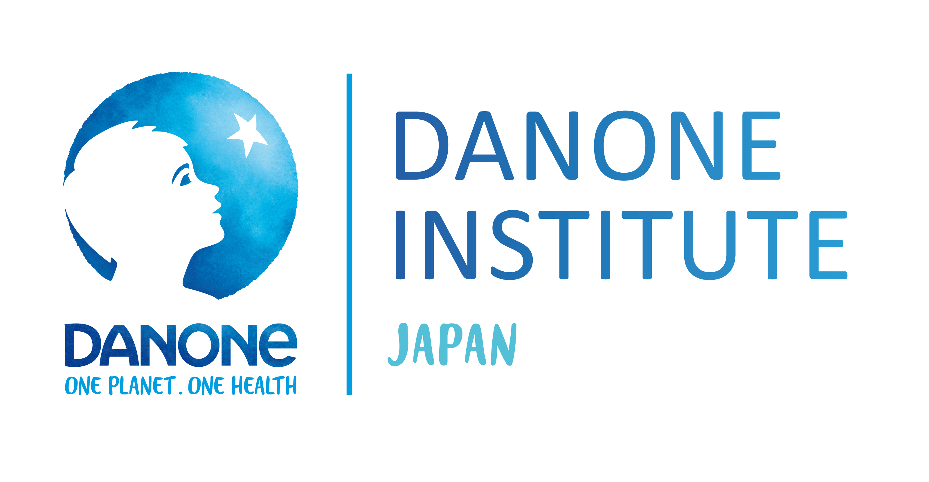
2022 DIJF Research Grant Winners
General Researchers Grant
Tomohide YAMADA
Institution: Department of Diabetes and Metabolic Diabetes, Graduate School of Medicine, The University of Tokyo
Title: Personalized and standardized approaches to healthcare utilizing artificial intelligence.

Tomoko KAWAI
Institution: National Research Institute for Child Health and Development
Division of Fetal Development, Department of Maternal-Fetal Biology, National Research Institute for Child Health and Development
Title: Elucidation of the effects of perinatal nutritional environment on infant’s lifelong health

Yorito HATTORI
Institution: National Cerebral and Cardiovascular Center
Title: Elucidating the mechanism of human gut dysbiosis and development of novel treatment for stroke based on ‘Brain-gut axis’.

Young Researchers Grant

Hanako NAKAJIMA
Institution: Department of Endocrinology and Metabolism, Kyoto Prefectural University of Medicine
Title: Effect of probiotics on prevention of sarcopenia in older people with type 2 diabetes mellitus through the metabolome

Fumina OHSAKA
Institution: Division of Applied Bioscience, Research Faculty of Agriculture, Hokkaido University
Title: The role of microRNA on health promoting effects of prebiotics and probiotics

Daiki WATANABE
Institution: National Institutes of Biomedical Innovation, Health and Nutrition
Title: Association between temporal changes in diet quality and concurrent changes in dietary intake, body mass index, and physical activity among Japanese adults: A longitudinal study
Tomonori KAMIYA
Institution: Osaka City University Graduate School of Medicine, Molecular and biomedicine, Department of Pathophysiology
Title: The mechanism of oral cancer development and exploration of probiotics for its prevention focusing on the oral environment and microbiota

