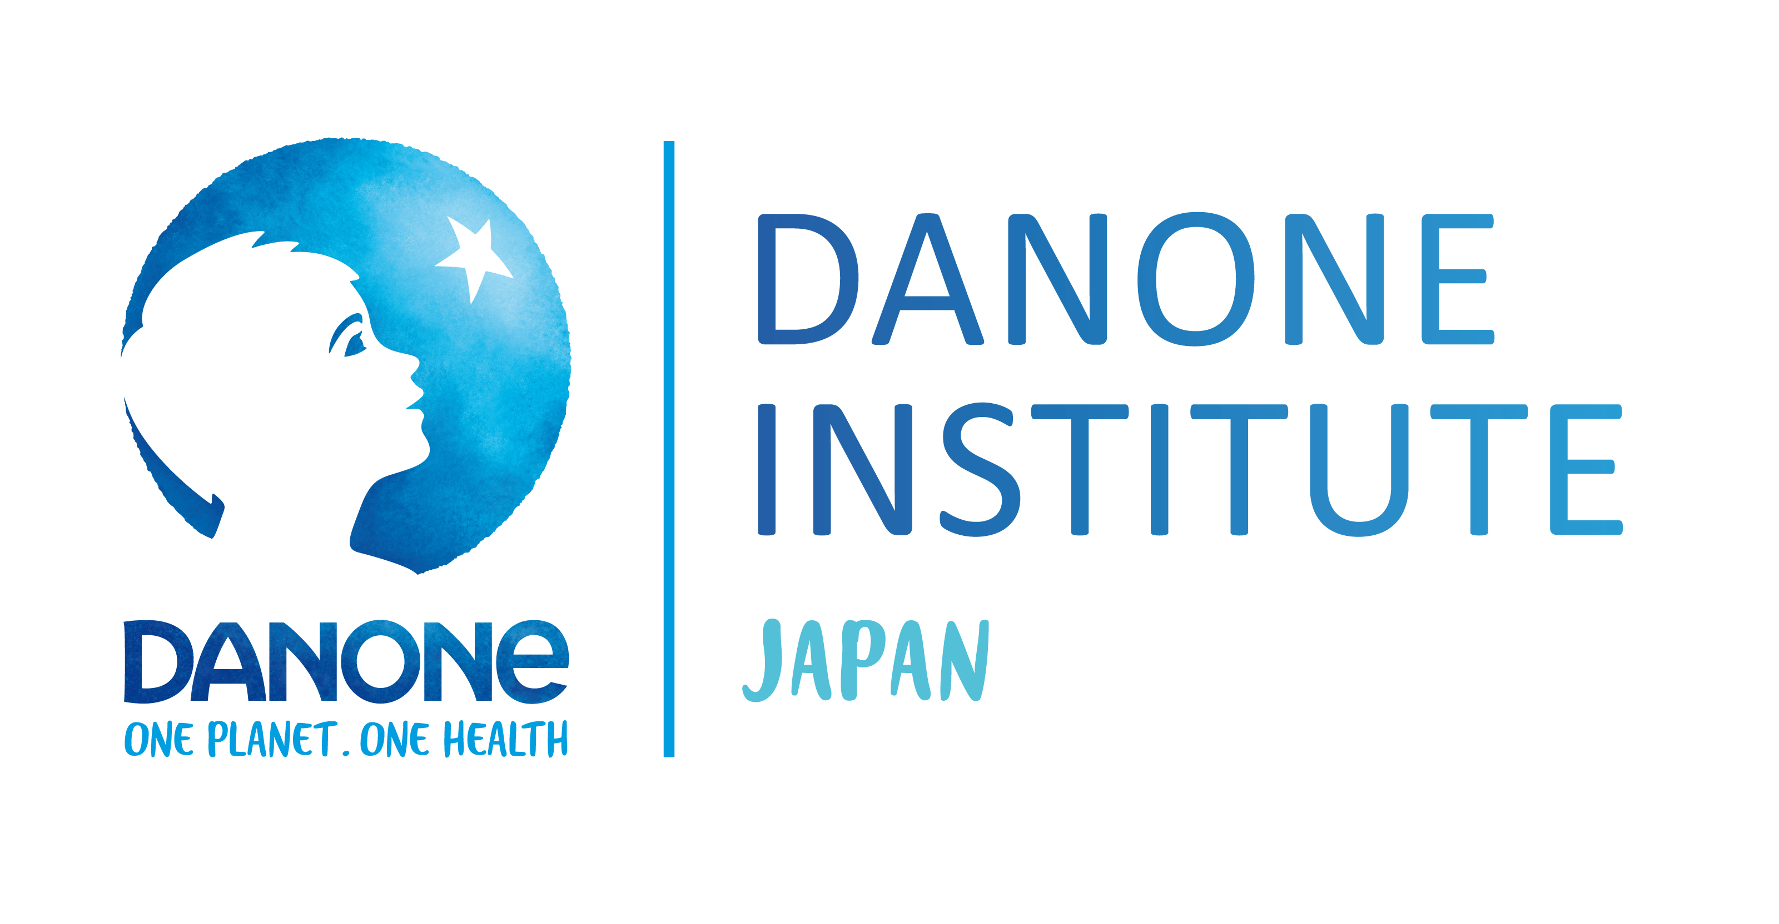
2021 DIJF Research Grant Winners
General Researchers Grant
Satoshi KIDA
Institution: Laboratory of Nutritional Chemistry, Department of Applied Biological Chemistry, Graduate School of Agriculture and Life Sciences, The University of Tokyo
Title: Understanding mechanisms underlying regulation of memory by essential amino acids and the application for treatment of cognitive disorders

Makoto MURAKAMI
Institution: Laboratory of Microenvironmental Metabolic Health Sciences, Graduate School of Medicine, The University of Tokyo
Title: Mobilization of phospholipid-derived lipid mediators in milk and their effects on offspring

Yosuke KURASHIMA
Institution: Innovative Medicine, Graduate School of Medicine and School of Medicine, Chiba University
Title: Screening and verification of Lactobacillus spp. strengthen intestinal barrier

Young Researchers Grant

Kosuke MOTOKI
Institution: Department of Food Management, School of Food, Agricultural and Environmental Sciences, Miyagi University, Sendai, Japan
Title: Elucidating the processing of nutritional information in the elderly: Evidence from a combination of eye-tracking and experimental psychology methods.

Thanutchaporn KUMURUNGSEE
Institution: Hiroshima University
Graduate School of Integrated Sciences for Life Program of Food and AgriLife Science
Title: Exploration of potential roles of homocarnosine in brain and its application in pre/probiotic foods

Hayato TSUKAMOTO
Institution: Faculty of Sport and Health Science, Ritsumeikan University
Title: The investigation of breakfast patterns and 2nd meal impacts on the relationship between cognitive function and neurovascular coupling; a fMRI study
Tomohiro IWATA
Institution: University of Tsukuba
Title: Does spermidine suppress age-related skeletal muscle atrophy?

