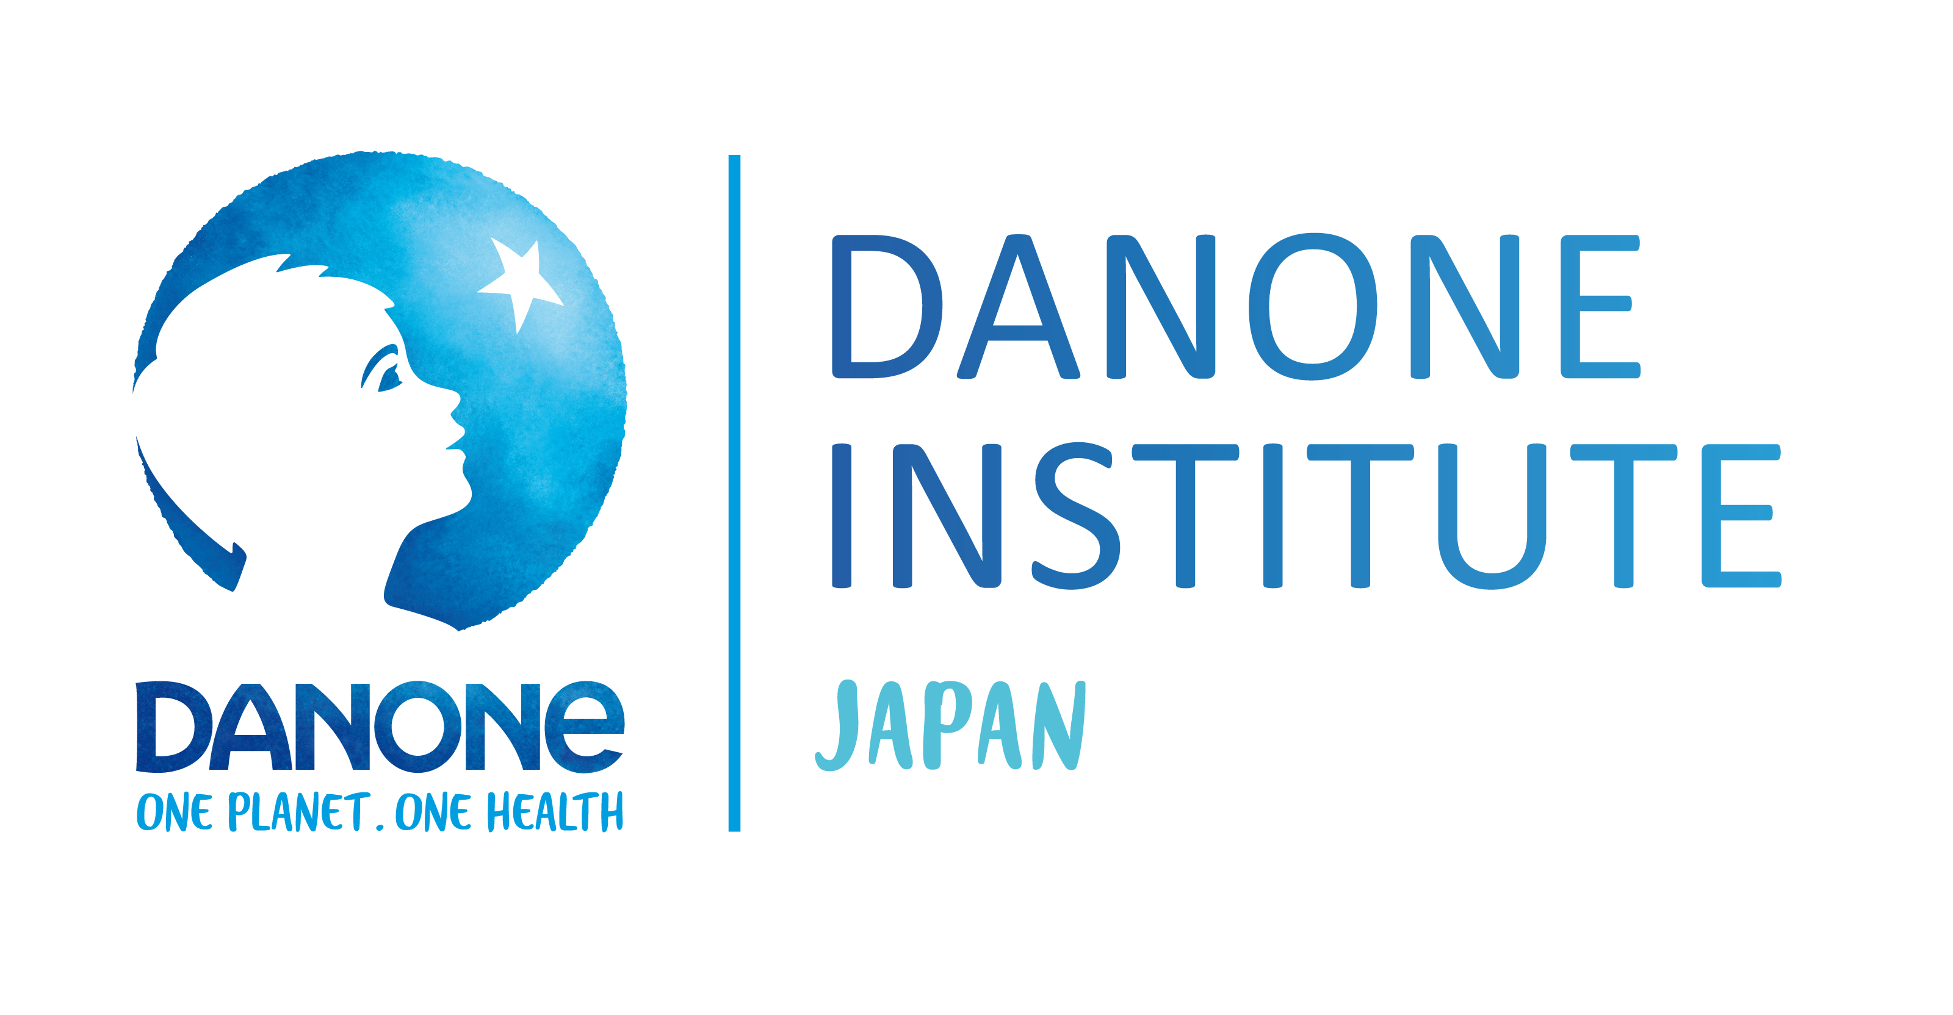
2020 DIJF Research Grant Winners
General Researchers Grant
Naoki Saji
Institution: Center for Comprehensive Care and Research on Memory Disorders, National Center for Geriatrics and Gerontology
Title: Effects of both gut and oral microbiome and protective efficacy of the Japanese diet pattern on cognitive function and orthobiosis in the elderly.

Tsutomu Sasaki
Institution: Laboratory of Nutrition Chemistry, Division of Food Science and Biotechnology, Graduate School of Agriculture, Kyoto University
Title: Does the continuous usage of non-nutritive artificial sweetener increase the risk for developing life-style diseases by altering cephalic phase response?

Takayuki Ogino
Institution: Department of Gastroenterological Surgery Graduate School of Medicine, Osaka University
Title: Impacts of food passage on gut flora and intestinal immune system.

Mari Mori
Institution: Department of Health Management, School of Health Studies, Tokai University
Title: Basic Studies on Evidence-based Food Education for Recovering Healthy Longevity in Okinawa: Optimum Salted Washoku for Health for All.

Young Researchers Grant

Michiko Furuta
Institution: Section of Preventive and Public Health Dentistry, Division of Oral Health, Growth and Development, Faculty of Dental Science, Kyushu University
Title: Multiple epidemiology studies on lactic acid food contributing to oral health.

Toshiko Takezoe
Institution: Graduate School of Medicine, The University of Tokyo
Title: Energy and nutrient intakes of children with severe motor disability in Japan.

Atsushi Haraguchi
Institution: Laboratory of Physiology and Pharmacology, Department of Electrical Engineering and Bioscience, School of Advanced Science and Engineering, Waseda University
Title: Elucidation of the mechanism of depression caused by disrupted meal rhythm.

